Offensive Decoy Technology

Created For:

Computer Science Department -Professor Moshe Cohen

Applications used:

MS-word, Excel, Java, HTML, JSP

1. **Introduction**

1.1 Cover or Title page, showing the system’s name and logo.

1.1.1. Information Analysis and System Design, CS-670-A, **Team #1.**

1.1.2. Sacred Heart University, 5151 Park Avenue, Fairfield, CT.

1.1.3. Trimester year, and date created

1.1.4. Team Members – First-names, MI, Last-names, e-mail, Phone

1.1.5. Applications used to create **this** document – Word, PPT, Excel, Visio, etc…

1.2 Table of Contents, this document, use MS Word to add leaders (……..) & page numbers

1.3 Abstract 15

1. **Preliminary Investigation Phase** – Also called Scope Definition Phase*.*

Determine “If the project or problem worth looking at?”

*If yes, establish the size and boundaries of the project, project vision, any constraints or limitations, required participants, budget, and schedule.*

2.1. Summary of problems, opportunities and/or directives 11

2.2. Statement of preliminary scope 11

2.2.1. What type of data describe the system being studied 11

2.2.2. What business processes are included in the study? 12

2.2.3. How does the system interface with users, locations, and other systems? 12

2.3. Assess project worth in terms of Cost vs. Value 14

2.4. Preliminary project plan 15

2.4.1. Master Schedule for entire project 15

2.4.2. Resource assignment for entire project 15

1. **Problem Analysis Phase** – Understand the current (existing, old) system!

*Focus on system owner’s & system user’s view of data, process, and interface.*

3.1. Study the problem domain 16

3.1.1 Data collected by the system 16

3.1.1.1. Methods 16

3.1.1.2. Storage 16

3.1.1.3. Personnel involved 16

3.1.1.4. Time involved 16

3.1.1.5. Sample data model

3.1.2. For each report reproduced by the system 16

3.1.2.1. List name and format 16

3.1.2.2. List inputs and outputs 16

3.1.3. Processes currently implemented 17

3.1.3.1. List all processes 17

3.1.3.2. List all hardware and software used 17

3.1.3.3. Functional decomposition diagram of current system 18

To identify the major processes (functions) in the system and break them down (decompose them) all the way down to the "event" level.

3.1.4. System interfaces 18

3.1.4.1. Locations served by the system 18

3.1.4.2. Users served by system 18

3.1.4.3. Other systems it interacts with if any 18

3.1.4.4. Context diagrams of current system 19

To identify the scope of the system to be designed.

3.1.5. Current business structure hierarchy chart - organizational Chart of company 19

3.2 Analyze problems and opportunities 20

3.2.1. Define cause and effect for each problem 20

3.2.2. Opportunities 20

3.3 Establish system improvement objectives 20

3.3.1. State new system objectives. 20

What the project will accomplish, describe the specific, tangible products and deliverables that the project will deliver.

3.3.2. List new system constraints 20

3.3.2.1. Schedule 20

3.3.2.2. Cost 20

3.3.2.3. Technology 20

3.3.2.4. Policy 21

3.4 Re-evaluate and update project scope 21

1. **Requirements Analysis Phase** - *What* must the new system do & not do?

*Focus on system owner’s & system user’s view of data, process, and interface.*

4.1 Identify requirements. **(For objectives stated in 3.3.1**) 22

4.1.1 List, describe, and defend functional requirements in terms of 22

4.1.1.1. Inputs – data 22

4.1.1.2. Outputs – information 22

4.1.1.3. Processes - manual, automatic 23

4.1.1.4. Storage – database 23

4.1.1.5. Control - authorization, can & cannot do, or see 23

4.1.2. List and defend non-functional requirements 23

4.1.2.1. Performance 23

4.1.2.2. Ease of use 23

4.1.2.3. Cost savings 23

4.1.2.4. Timelines and deadlines 23

4.1.2.5. Training 23

4.1.2.6. Quality Management 23

4.1.2.7. Security and Audits 23

4.2. Analyze functional requirements using system modeling approach 24

4.2.1. Construct preliminary data model - Entity Relationship (ER) diagram 24

4.2.2. Construct preliminary process model - Data Flow diagram (DFD) 25

4.2.3. Construct preliminary Interface model - Context diagram 25

4.3. Master list of all requirements in terms of 31

4.3.1. Priority 31

4.3.2. Deadlines for each 31

4.3.3. Supporting requirements 31

* 1. Re-evaluation and update project scope 32

**5.** **Decision Analysis Phase** – Recommend and sell your solution!

*Focus on system owner’s & system user’s view of data, process, and interface.*

5.1. Identify candidate solutions 32

5.2. Analyze candidate solutions

5.2.1. Feasibility Analysis

5.2.2. Cost-Benefit Analysis

*Assume: Analysts $60, Programmer $40, Assistant $20*

5.2.2.1. Chart cost analysis of design

5.2.2.2. Chart cost analysis of hardware, software, miscellanies purchases

5.2.2.3. Chart cost analysis of system operation, and maintenance

5.2.2.4. Chart cost analysis of training

5.2.2.5. Analysis of budget, costs, and business benefits

5.3. Compare candidate solutions

5.4. Recommend a final "best" solution

*Consider the following criteria*

5.4.1. Operating environment or constraints

5.4.2. Hardware new and existing

5.4.3. Software new and existing

5.4.4. Staffing new and existing

5.4.5. Training new and existing

5.4.6. Installation requirements

5.4.7. Performance requirements

5.4.8. Development requirements

5.4.9. Reports to be delivered

5.4.10. Security requirements

5.4.11. Auditing requirements

**6.** **Design Phase** – *How* will the new system implement technology**?**

*Focus on system designer’s view of data, process, and interface.*

6.1. Design the application architecture

6.1.1. Networks - intr**a**net and/or int**e**rnet

6.1.2. Database distribution - client/server or network

6.1.3. Customization and integration of “off the shelf” software

6.1.4. User interface technology – with other users

6.1.5. System interface technology – with other systems

6.2. Construct detailed models

6.2.1. Context model

6.2.2. Data flow diagram (DFD) decomposition to system modules

6.2.3. Software structure chart showing module hierarchy on one page

6.3. Design the system database

6.3.1. Construct the detailed entity relationship (ER) diagram

6.3.2. Perform the 3 normalization forms, listing dependencies

6.3.3. Chart entities, attributes, domain, primary keys and foreign keys

6.3.4. Data dictionary of all the attributes

6.4. Design the system interface for each model include the following

6.4.1. Module name

6.4.2. Parameters passed and their meaning

6.4.3. Description of module function

6.4.4. Input

6.4.5. Output

6.4.6. Called module names

6.4.7. Report layouts

6.4.8. Screen layouts

6.4.9. Algorithms, pseudo-code or story

6.4.10 Error messages and meaning

6.4.11 Using Microsoft Word (Insert, Shapes), create “Callouts” to explain each entry

**7. Construction Phase –** Develop, install, & test the new system components.

In this phase you will transform (Code and Test) approved architecture and design into a working system that is consistent with functional and technical requirements identified during earlier phases of the solutions life cycle.

7.1. Build and Test Networks - intr**a**net and/or int**e**rnet (if necessary)

7.2. Build and Test Databases

7.3. Install and Test New Software Packages (if necessary)

7.4. Write and Test new Programs

7.5. Schedule - use the start and end dates of **this** Academic year

7.6. Staffing - show owners responsibility

7.6.1. Staffing hierarchy chart

7.7. Acceptance testing

7.7.1. Plan

7.7.2. Schedule

7.7.3. Acceptance Criteria

7.8. Tools to be used in the proposed system

7.8.1. Data Base

7.8.2. Screen generators

7.8.3. Hardware - servers, etc.

7.9. Maintenance documentation

7.9.1. List of modules

7.9.2. Auditing procedures

7.9.3. Backup and restore procedures

7.9.4. List of maintenance contacts with email and phone numbers

7.9.5. List of vendors, consultants and external contacts

**8.** **Implementation Phase –** Deliver your system into production (operations).

Provide for a smooth transition from the current (old) system to the new system.

8.1. Conduct System test

8.1.1. Plan

8.1.2. Schedule

8.1.3. Acceptance Criteria

8.2. Prepare Conversion Plan

8.2.1. Plan

8.2.2. Schedule

8.2.3. Systems acceptance test

8.3. Install Databases

8.3.1. Populate the new system’s databases

8.3.2. Hardware - servers, etc.

8.4. Training

8.4.1. Plan how to

8.4.2. Schedule

8.4.3. Training manuals, User guides

8.5 Convert to new system

8.5.1. Stakeholders discuss experiences

8.5.2. Agree on future enhancements – Clearly documented

8.5 3. What did we learned – Openly documented

**9.** **Alphabetical Glossary** & **Index**

9.1 List and explain all key terms, showing where they can be found in this manual

**10.** **Bibliography, References** & **Citations -** Microsoft Word, Reference tab

Use the Modern Language Association (MLA) formatting style.

10.1. Books

10.2. Articles

10.3. Internet or Web sites

10.4. Any other source

**11.** **Contacts**

11.1 List each stakeholder’s contact information and expertise as related to the system.

# Introduction

Abstract

Offensive decoy technology is a system which provides the user to secure[1] information in the server using decoy[2] technology. The users[3] are those who have valid credentials[4] to use this system. In this system users are also called as insiders[5]. In the security point of view, all the remote-users[6] are to be treated as attackers. When the user registers to our system user needs to answer some challenging questions and select a specific time to download files along with valid details required to use the system. From answers given by the user for that challenging questions the system provides the security answer by performing some operations within the system for downloading files. If the insider or attacker wants to download the file from the system user should provide security answer provided at the time of registration. If the security answer is incorrect or if it is not a specified time to download the file then the system provides an identical file which is not an original file which is also called as decoy file to the insider/attacker. Apart from that, in our system user can also view how many times each file have been downloaded by the insider and attacker.

Goals

The main goal of our system is to secure the information of insider from attackers by using a decoy technology. This system uses the server as a domain for it and it is a replacement for the encryption mechanism that is used to secure the data in the server. Especially for text files. Users have to register for the product in order to upload their files. Registered users can download files from the system by giving a security answer provided to the user at the time of registration to get original file and strangers can’t get original files.

# Preliminary investigation phase

## Summary of problems, opportunities and/or directives

The various problems in the current system could be identified as follows:

* So numerous[7] encryption[8] keys have failed to keep the user’s information from theft attacks in the server.
* Researchers have done research on encryption and decryption but not able to give protection for the user’s information in the server.
* If the user details such as username and password is hacked then there is no security for user’s information.

## Statement of preliminary scope

The main Scope of Offensive decoy technology is to secure the data by using the decoy innovation technology in the server. Offensive decoy technology will be used for securing the data through the server about the file information before it is going to download using a security answer provided to the user and specific time selected by the user at a time registration to download that file.

### Types of data in the system

**Services:**

* Service name and its description
* Benefits and details of service

**People:**

Administrator:

* Name, password issued by the company, the admin will provide the activities requested by the insider.

Client:

* First Name, Last Name, email, contact number, password, address, time frame to download the file in particular timing only and security questions for providing a security to the files.

### Business processes

By using this system the user can maintain information more secure in an easier way. They can use Offensive Decoy Technology application from their computers and mobile devices which having the network service.

### User Interface

**People**

**Admin:**

* Admin controls the entire web application and can modify the contents and the information in the application.
* Admin can add or delete the clients.
* Admin will give authorization[9] to the newly added users after confirming the user details.

**Clients:**

* Clients can create and update their account.
* Clients can view their files whenever they want.
* Clients can upload their files whenever they want.
* Clients can download their original files by giving the security answer provided to them and at specific time selected at the time of registration.
* If client gave incorrect security answer or it’s not a specific time to download the files then the user also gets a decoy file with identical[10] information.

**Attacker:**

* Attacker can login with insider details whenever he wants but he can’t download user files unless attacker knows the exact security answer provided to the user at the time of registration.
* Apart from this attacker should also know the exact time selected by the user to download the files.
* Unless attacker knows this details. Attacker cannot get the user files.

**Application Usage Location**

* + - Offensive decoy technology is an application that can be used in any device that support web application
    - This system can be used anywhere from the device that having internet access.

**Others**

* Web based technology[11].
* Personal computer – Operating system – windows.

## Project Worth (Cost vs Value)

### Estimated Cost of ProjectValue of project:

The project must need worth the cost as it show the following process

We should give more flexible to customers. By giving more security about types of news and how the news is important to the people. News are very important, so instructions are important before sales to customer

-Maintaining standards in quality of product

-Accounts should be clear and more detailed

## Preliminary Project Plan

### Master Schedule

The project is require to be developed in java. Keeping in view the estimated project scope, implementation schedule, vendor implementation will estimated to get accomplished in a period of 3 months.

### Resource assignment

Software:

* Java, HTML, JSP.
* Microsoft Office Suite
* Draw.io (for diagrams)

Hardware:

* Hardware for development of the application,(desktops/laptops, mouse, keyboard, printer)

Personnel:

* Programmers
* System Analyst
* Administrator
* Marketing Personnel
* Information system designer

# Problem Analysis Phase

## Study the problem domain

The main issue of present system is clients cannot keep their information securely on server. If the clients detail’s such as username and password is hacked then there is no security for user’s information.

### Data collected by the system

* Username and password.
* Files uploaded.
* Security Information.

#### **Methods**

* Users – Users information and required data will be filled.

#### **Storage**

* All data is stored within the servers and databases for all applicable application and to access the information.

#### **Personnel involved**

* Admin is the only person involved in the system because he protects the data from the attackers.

#### **Time involved**

* Variable – dependent on the user and user familiarity with the system.

### Reproduced by the system

#### **Name and format**

* Quality Report - Excel, PDF
* Input/output Report - Excel, PDF
* Users Interest Report - Excel, PDF

#### **Inputs and outputs**

* User data and information (input/output)
  + User information
  + Address, Email.

### Processes currently implemented

#### **Processes**

* + User will enter his/her details into input fields.
  + Then user inserts details of his/her.
  + In security users will get chance to write the required information for protecting their data.

#### **Hardware and software used**

* Hardware
  + Client/server system environment.
  + System users require personal computer or Mobile with web browser access to it.
* Software
  + Operating system and web browser application with internet access.
  + Software (both client/server and web-based applications)
  + User can access on any operating system which is having web browser compatibility.

#### **Decomposition diagram of proposed system**

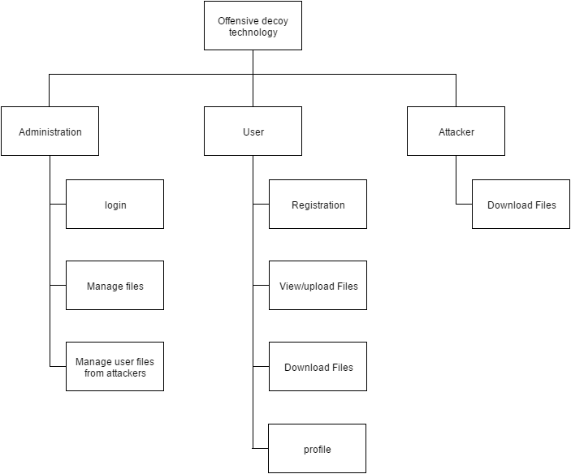

### System interfaces

#### **Locations served by the system**

* The offensive decoy technology Website serves in Fairfield, CT, USA.
* Can access 24/7 in online.

#### **Users served by system**

* User who are looking for the security for their information.

#### **Other systems it interacts with if any**

* Internet connection is required to access this service.

#### **Context diagrams of current system**

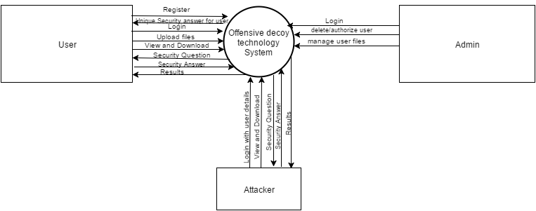

### Structure hierarchy chart - organizational Chart of company

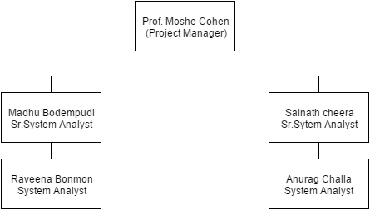

## Analyze problems and opportunities

### Problems

* User may sometimes give false details.
* Users might loss login details.
* Users may login with fake email ids.

### Opportunities

* We provide reliable methods to know those details.
* We authenticate login details in order to change the login details if necessary.
* When user registered first their email id has to be verified in order to eliminate fake Id’s.

## Establish system improvement objectives

### State new system objectives

Strategic Objectives

* By limiting non-premium user to access with Adviser to interact, to get promotion they had to be a Premium member

 Tactical Objectives

* To provide better Interactivity it suggests some suggestion in UI which is logically programed to do so.

### List new system constraints

#### Schedule

Start date:-01/12/2016

End date:-03/28/2016

#### Cost

The estimated cost of this system is around $81,600.

#### Technology

This system is a web based technology

#### Policy

The policies play an important role in maintaining a positive experience for everyone using our system. Be sure to check back from time to time, as these policies may change.

## Re-evaluation and update project scope

The Offensive Decoy Technology system, mainly focus on the Fairfield county city of the Connecticut. The user of the system are eligible to register with the system only.

# Requirements Analysis Phase

## Identify requirements

### List and describe functional requirements

|  |  |  |
| --- | --- | --- |
| Item | User | System Owner |
| Inputs | Create username and password - Ensures only authorized user can access the information. | Capacity of client to enter individual information - Desire to enhance Users consistence and diminish re-admission rates. |
|  | Enter right qualifications made at the time of registration. | Verifies the credentials entered to be matched with the database. |
|  | Update user details | Updates changes if any |
|  | Upload the information | Sync the information with the database |
|  | In case of Technical Problems Contact the Admin | Accepts and Provide the connectivity to users |
| Outputs | User can download his uploaded file according to the time selected in registration form by giving his answer to the security question asked. |  |
| Storage-database | Users Input Database | Admin can look into it. |
| Item | User | System Owner |
| Control | Users Personal record | Users personal record |
|  | On input details | User, files. |
|  | Feedback | Users Service Page |
| Performance  Ease of Use  Cost Savings  Timeliness & Deadlines Time: | It depends on Browser rendering and latency of network  user and password login  Navigation Bar links will leads to respected pages looking for  As Goals are set to time bond alerts will show up.  Based on goals time limit Adviser may advise based on system timeline | Booking Appointments for the Meet-up have reduced. |

## Analyze functional requirements using system modeling approach.

### Construct preliminary data model - Entity Relationship (ER) diagram.



### Construct preliminary Interface model - Context diagram.



Level-0



Decomposition to level 1.0 of DFD Level 0

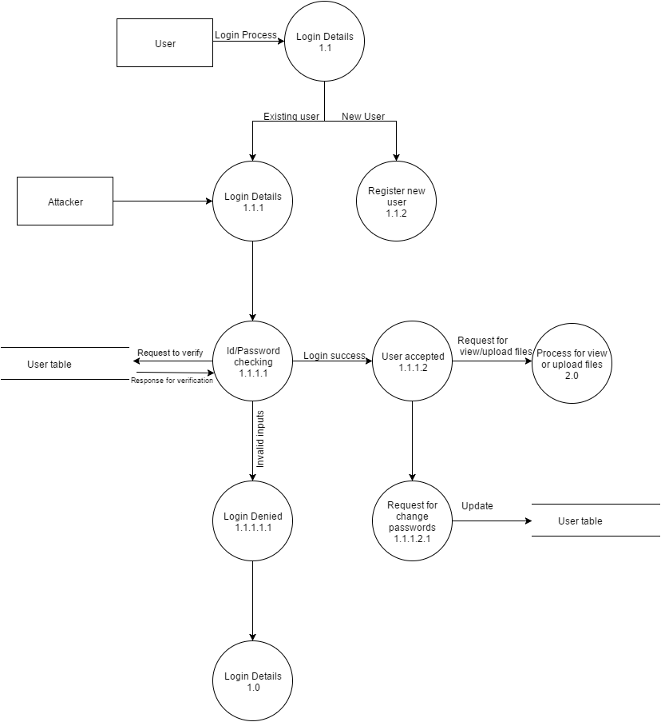

Decomposition for Level 1.1.2 of DFD Level 1.0



Decomposition to level 2.0 of DFD Level 0

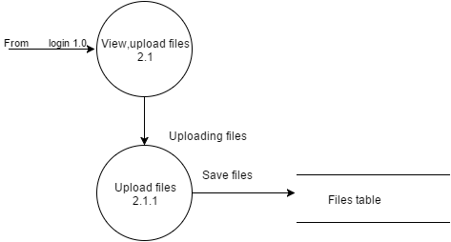

Decomposition to level 3.0 of DFD Level 0



## Master List of all requirements

|  |  |  |
| --- | --- | --- |
| Functional | Requirements | Priority |
| Inputs – Data | User:   * Create username and password. * Agree terms and conditions. * Insert user details. * Request to secure the file.   Admin:   * Manage the files. | 1 |
| Outputs | User:   * Download files by giving appropriate answer to the security question. | 1 |
| Processes – manual | User:   * Registration. * Login to Web Portal (manual)   Admin:   * Spam filtering. | 1 |
| Processes – automatic | User:   * Logical instructions. | 1 |
| Storage – databases | * User input database | 1 |
| Control - interfaces | User:   * User Dynamics.   Admin:   * Watch files. | 1 |
| Non-Functional | Requirements | Priority |
| Performance | User:   * This application must be available 24/7 for Users and Admin. | 1 |
| Ease of use | User:   * Directions for creating user name and password should be simple. * Links provided for ‘Help’, ‘Forgot user name’ and ‘Forgot password’ with hint button for security question * Ability to reset password with the help of security question. | 1 |
| Cost savings | User:   * No need to pay for the registration process. | 1 |
| Security and audits | * This website uses secure HTTP to communicate. * User details are in privacy limits. * Email authentication | 1 |

## Re-evaluation and update project scope

The Offensive Decoy Technology system, mainly focus on the Fairfield county city of the Connecticut. The user of the system are eligible to register with the system only.

# Decision Analysis Phase

## Identify candidate solution required

Based on the research upon the existing system for the convenience of the customer, it is suggested that new system has to be built in order to fulfill the requirements of the customers and secure the information of the customers all over the world. This application provides the users to upload the files and an download his files whenever he wants according to the time selected in registration form and providing answer to the security question which matches the database otherwise fake file will be downloaded to the user if doesn’t provide same answer which doesn’t matches the database. This helps clients to secure their file information.

Option:

* On-line System.
* Client’s access application to select their own choice and use the services provided.
* Administrators access system to manage data in the database.
* System is to comply with all Functional and Non-Functional Requirements as specified in Section 4.1 of this document.
* Database component of the system will utilize SQL server (2012 version)

## Create customers required format

The options listed above in section 5.1, those options fulfill the primary capabilities and the requirements of the user.

Option 1

* Is the best solution as it fulfills all the requirements of the user.

Option 2

* Is not best as the requirement, as it causes the project to exceed constraints set for schedule and budget.

## Final best format

### Operating environment or constraints

* The system will maintain detail description of information, obtained from the client’s, general descriptions, and intended heading as to cross reference with known reviews from the client’s.
* Administration, development, and maintenance of the system can be performed either remotely (via internet connection) or on site.

### Hardware new and existing

* Desktops, laptops, keyboards, mouse and printers used to develop and maintain system.
* Much of the hardware will consist of newly developed systems to meet the new need.

### Software new and existing

* HTML 4 and JavaScript for client side programming and user interfaces
* JAVA (using for front end application development)
* Microsoft SQL server (using for back end application development)
* Microsoft Visio (using for UML diagrams)
* Microsoft office (using for open-source documentation, presentation)

The system will consist mainly of a secure database that holds the individual’s information that is necessary to the function of the system. It will be open to the security personnel and be able to communicate with the other parts of the database as needed.

### Staffing new and existing

* 2 System Analysts
* 2 Programmers
* Client’s

There will be increased need for technologically knowledgeable security personnel to operate and understand this system. They will have to be able to distinguish between the normal system messages that come through and the more important warnings or alerts.

### Training new and existing

* No formal training will be needed as its user friendly and self-explanatory.
* Online/internal help screens will guide person and define screen choices.

### Installation requirements

Installation required pertains to tools used for system development and administration including Java, Microsoft office (or equivalent), Microsoft SQL server DBMS, Microsoft Visio using for UML diagrams)

### Performance requirements

* A 5sec response time from the server is expected between the request and load time. (May vary with internet connectivity response time.)
* Offensive Decoy Technology for Server Attacks interface will be available as long as there is internet connectivity.
* Data maintenance will be scheduled at monthly intervals or when required.
* Data flow less then 2MG. Most case less than 250K.
* Number of Requests to the system will be user dependent.

### Development requirements

* The system is developed based upon the user’s requirements.
* The intended programming language used to build this web application is java, Server-SQL server 2012 (version and above).

### Reports delivery requirements

* The system shall provide Customer activity reports to administrator.
* The system can be updated frequently (weekly, monthly, daily) and providing the requirements to the end users.
* The system always checks for updates and pop-up is shown on help tab on the interface.

### Security requirements

* The statement must be signed by the project member prior to being granted access to the department’s information. The Statement must be renewed annually when required.
* Provide Authorization-Department of vendor’s information or in locations where it might be accessed.

### Auditing requirements

* Provide management with reasonable assurance that control objectives are being met.
* System provides customer’s surveys to marketing team on correct action.
* Where there is significant control weakness, to substantiate the resulting risk.

## System implementation

### Testing and evaluation procedure

* System Analyst would create test scenarios based on the use cases identified in the system.
* Testing would be performed on various browser systems and in various platforms to check for compatibility.
* Data validation is to be implemented at all the interfaces where the data is being accepted from the system user.
* Re-evaluation of testing procedures will be done from time to time by the System Analyst.
* Fault testing is also performed by programmers who are not involved in the system development.
* Apart from these the system is tested for response time, and availability.
* Once the application is fully tested, the system is then given to some set number of Clients or Vendors to understand system usability.

### Schedule of implementation

|  |  |  |
| --- | --- | --- |
| Tasks | Start Date | End Date |
| Data tables design | 11/2015 | 11/2015 |
| Build and Test First Iteration | 11/2015 | 11/2015 |
| User Group testing and feedback | 11/2015 | 11/2015 |
| Modifying the interfaces based on feedback | 11/2015 | 11/2015 |
| Final Box and test Phase | 11/2015 | 11/2015 |
| Stress Tests | 11/2015 | 11/2015 |
| Launch of offensive decoy technology | 11/2015 | 11/2015 |

### Acceptance criteria

* All the users should get the acceptance of the System Analyst.
* System Analyst would review the feedback and response from the stakeholders and the Client and Vendors.
* Fault testing result should be 3% of error of acceptance.
* All the functional & non-functional requirements planned for the first implementation plan will be implemented and fully tested.

# Design phase

## Design the application architecture

### Network

* The user must have an access to the internet in order to utilize the services provided in the system.
* Admin has the main functionality throughout the system; admin is responsible for management of overall database resources.

### Database distribution – client/server or network

AS the main functions of the system is to store and retrieve the information this functions are managed by SQL server in this system.

### Customization and integration of off the shell software

The Offensive Decoy Technology for Server Attacks is customizable with the expectation of adding services.

### User interface technology

This system is developed for the clients who can access to the services and utilize the services.

### Programming languages to be used

* JAVA
* HTML/CSS/Java script
* Structured Query Language(SQL)

## Construction detailed model

### Context Diagram

** `**

### Decomposition of Context Diagram – Data flow diagram – level 0:

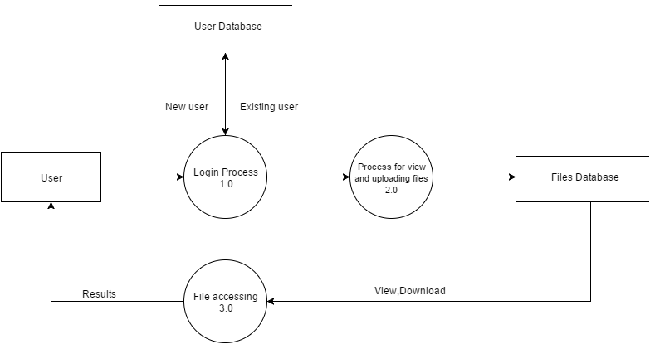

Decomposition to level 1.0 of DFD Level 0

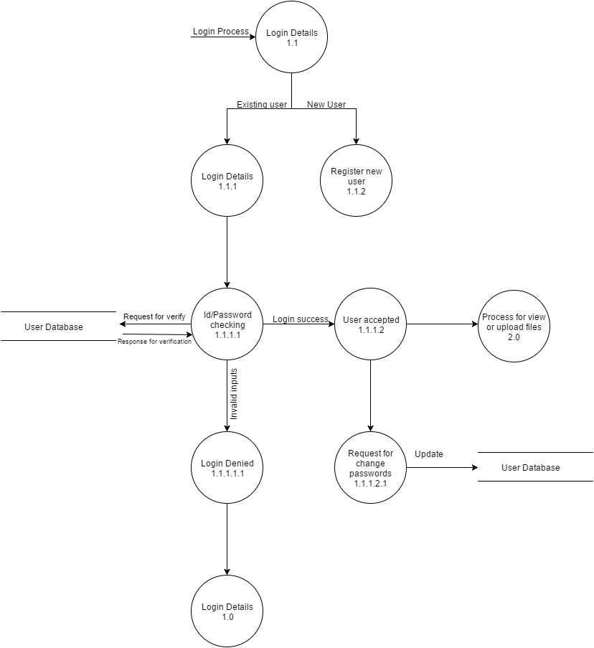

Pseudocode:

1. When the Admin wants to login. Admin has to login with user id/ password provided by the company.
2. If the user’s username/password is valid then he/she is the existing user.
3. When the user logins to our system he enters into a view files or upload files page.
4. Here he can upload or view his old files uploaded by him.

Decomposition for Level 1.1.2 of DFD Level 1.0

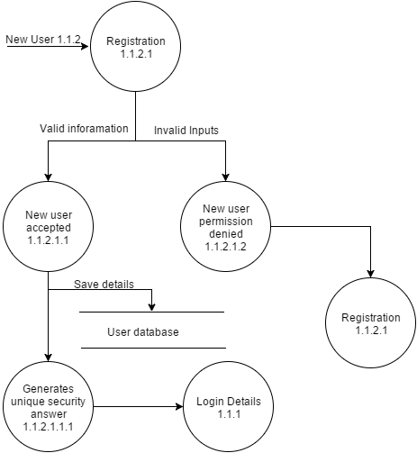

Pseudocode:

1. If he/she is the new user. Then he/she has to process the registration.
2. Then he/she enters the valid details then the account has been created successfully.
3. The new user who wants to register into the web page has to enter their first name
4. The new user who wants to register into the webpage has to enter their last name.
5. The new user who wants to register into the webpage has to enter their age.
6. The new user who wants to register into the webpage has to mention their gender.
7. The new user who wants to register into the webpage has to enter their address.
8. The new user has to enter the unique email id which he/she log into the webpage.
9. The new user has to create the password to enter the webpage.
10. The new user has to enter the phone number to complete his/her registration.
11. The new user has to select the time frame to download files from the server.
12. The new user has to give some answers to challenging questions so that system generates a unique security answer by performing some operations within the system so that he can keeps information secure from attackers.
13. After successful registration he goes to login page.

Decomposition to level 2.0 of DFD Level 0



Pseudocode:

* + - 1. If the user uploaded his files he can view his files in this page.
      2. If user wants to upload his files he can upload his files here by clicking upload link.
      3. The uploaded files are saved in a files table.

Decomposition to level 3.0 of DFD Level 0

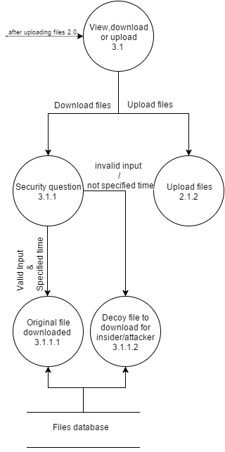

Pseudocode:

1. After uploading his files he can download his files whenever he wants.
2. User can download files by providing a security answer provided to him at the time of registration.
3. If the answer doesn’t match to the database he can get a decoy file/
4. If the security answer is correct if the file is not downloaded in the time frame then he will get a decoy document.
5. If the security answer is correct and the file is downloaded in a selected time frame then user will get original file uploaded by the user.
6. If the attacker wants to download user’s files then he can’t download files because attacker should know both security answer and time frame by the user to download the file which is impossible to hack the users files so the attacker gets decoy document created by the system.

## System Database

### Entity relationship(ER Diagram)



|  |  |  |  |  |  |
| --- | --- | --- | --- | --- | --- |
| **Column Name** | **Data Type** | **Primary Key** | **Foreign Key** | **Null** | **Description** |
| User ID | Varchar2(15) | Y | N | NOTNULL | User id is the primary key in the user table |
| Password | Varchar2(15) | N | N | NOTNULL | Password is the password user to enter into the system. |
| Confirm password | Varchar2(15) | N | N | NOTNULL | confirm password is the password used to validate using registration enter into the system. |
| Date Of Birth | Varchar2(15) | N | N | NOTNULL | DOB is the birth date of the user. |
| User Address | Varchar2(15) | N | N | NOTNULL | Address of the User |
| State | Varchar2(15) | N | N | NOTNULL | State of the user |
| City | Varchar2(15) | N | N | NOTNULL | City of the user |
| Zip code | Varchar2(15) | N | N | NOTNULL | Zip code |
| User email id | Varchar2(15) | N | N | NOTNULL | Emailed of the user |
| Admin id | Varchar2(15) | Y | N | NOTNULL | Administrator id the primary key |
| Admin email id | Varchar2(15) | N | N | NOTNULL | Address of the admin |
| File Id | Varchar2(15) | Y | N | NOTNULL | File id is the primary key in the user table |
| File Size | Varchar2(15) | N | N | NOTNULL | File size is the size of the file |
| File Name | Varchar2(15) | N | N | NOTNULL | File name is the name of the file |

## Attributes and Operations

|  |  |  |  |  |
| --- | --- | --- | --- | --- |
| **Log in Interface** | | | | |
|  | **Function** | **Input** | **Expected Results** | **Description** |
| A1 | Username | Account Username | N/A | Users logging in to the Offensive Decoy Technology for Server Attacks website will enter their username in this field. The username will be created by the user once they have completed registrations. |
| A2 | Password | Account password | Users password | After entering the username, the user will input the password that they have created for their account. Users will also have to be required to create their passwords upon registration. |
| A3 | Login | Click On Login | Open Offensive Decoy Technology for Server Attacks website | By clicking the submit button it navigates the user to the Offensive Decoy Technology for Server Attacks advisory website |

|  |  |  |  |  |
| --- | --- | --- | --- | --- |
| **User Registration Interface** | | | | |
|  | **Function** | **Input** | **Expected Results** | **Description** |
| B1 | Name | Account Username | N/A | The username will be created by the user once they have registrations. |
| B2 | Email | User Email Address | N/A | The Email is used to communicate with the user. |
| B3 | Password | Account password | Users password | This is used to make the user account secure. |
| B4 | Re-Password | Account password | Users Re-password | This is to re-enter the password. |
| B5 | Submit | Click On Submit | Create Account | By clicking the submit button it navigates the user to the Offensive Decoy Technology for Server Attacks website once the registration is successful |

## Design the system database

Perform 3rd normal form normalization listing dependencies and table

## Figure Table

## Prototype

# CONSTRUCTION Phase

## Build and Test Networks

## Build and Test Database

## Install and Test New Software Package

## Write and Test new Programs

## Schedule

01/11/2016

03/28/2016

## Staffing

System owners are usually tend to be interested in the bottom line like how much the value for what profits will the system return to the system.

### Staffing Hierarchy chart



## Acceptance testing

Acceptance testing is one sure way to reduce or eliminate change request, and drastically reduce project costs. It is an effective with a high rate of return for those who take time to implement and follow its discipline.

### **Plan**

### **Schedule**

**7.7.3** **Acceptance Criteria**

## Training

Arranging the system requires the user to characterize what the issue is. The arranging may likewise incorporate how the user might want to take care of the issue. Characterizing the extent of the issue is additionally vital in this stage too. Characterizing the extension serves to keep the undertaking from scope creep. Once the issue is dead set, and one or more arrangements have been chosen, wanting to execute the arrangement starts. Various situations may be established to focus the best approach for executing the system.

## Tools to be used in the proposed system (Data Base)

Database design is the process of producing a detailed data model of a database. This logical data model contains all the needed logical and physical design choices and physical storage parameters needed to generate a design in a data definition language, which can then be used to create a database.

## Maintenance documentation

The goal of the support stage is to keep the system running at a satisfactory level. This discusses types of maintenance and techniques for managing maintenance.

## Staffing - hierarchy chart

Programmer

User interface developer

Database Admin

System Analyst

Project manager

System owner

## Future enhancements

The Offensive Decoy Technology for Server Attacks, in future we are trying to get feedback from customers such as security provide for files, customer’s feedback, etc.

## What did we learned

The Offensive Decoy Technology for Server Attacks system documentation system helped us to know the importance of how to secure the document and especially the diagrammatic representation flow of explanation, and how to divide and organize the work.

# Implementation Phase

## Conduct System test

8.1.1 Plan

8.1.2 Schedule

8.1.3 Acceptance Criteria

**8.2 Prepare Conversion Plan**

8.2.1 Plan

8.2.2 Schedule

8.2.3 System acceptance Test

**8.3 Install Database**

8.3.1 Populate the new system’s database

8.3.2 Hardware

**8.4 Training**

8.4.1 Plan

8.4.2 Schedule

8.4.3 Training manuals, User guides

**8.5 Convert to new system**

8.5.1 Stakeholders discuss experiences

8.5.2 Agree on future enhancement

8.5.3 What did we learned

# Alphabetical Order

|  |  |
| --- | --- |
| **9.1. A**  Authorization | 12 |
| **9.2. B** |  |
| **9.3. C**  Credentials | 10 |
| **9.4. D**  Decoy | 10 |
| **9.5. E**  Encryption | 11 |
| **9.6. F** |  |
| **9.7. G** |  |
| **9.8. H** |  |
| **9.9. I**  Insiders  Identical | 10  13 |
| **9.10. J** |  |
| **9.11. K** |  |
| **9.12. L** |  |
| **9.13. M** |  |
| **9.14. N**  numerous  **9.15. O** | 11 |
| **9.16. P** |  |
| **9.17. Q** |  |
| **9.18. R**  remote-users | 10 |
| **9.19. S**  Secure | 10 |
| **9.20. T**  Technology | 13 |
| **9.21. U**  Users | 10 |
| **9.22.V** |  |
| **9.23. W** |  |
| **9.24. X** |  |
| **9.25. Y** |  |
| **9.26. Z** |  |

# References

**10.1. Books**

• System analysis design methods – Sixth Edition

• IT project governance by Magnus Mahring.

• Mastering software project management by Hsiang Tao Yeh.

• Software project management in practice by Pankaj Jalote.

• Sample project provided by Professor Karen Haley

**10.2. Articles**

• Companies phase Decoy Technology.

### **•** [Offensive decoy technology and the Internet of Things - Dataversity](http://www.dataversity.net/the-future-of-cloud-computing-fog-computing-and-the-internet-of-things/)

.

**10.3. Internet**

[www.google.com](http://www.google.com)

[www.draw.io](http://www.draw.io)

[www.wikipedia.com](http://www.wikipedia.com)

[www.gliffy.com](http://www.gliffy.com)

[www.tutorialspoint.com](http://www.tutorialspoint.com)

<http://academiccommons.columbia.edu>

<http://esatjournals.net/ijret>

1. Protect
2. Identical information but not the original one.
3. A person who uses or operates our system.
4. Authorization
5. A person within a system, especially someone who keeps secret/private information unavailable to others.
6. Who does not have physical access to the system
7. many
8. most effective way to achieve data
9. Authorization is the process of giving the rights to access the information in the system.
10. Similar
11. Web based technology in the application that works only over the internet.